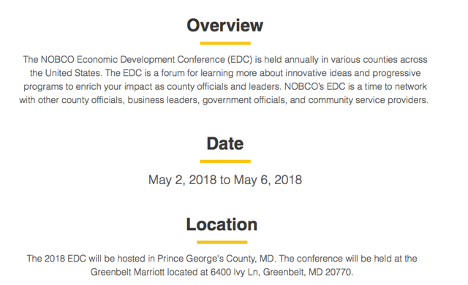

NOBCO ECONOMIC DEVELOPMENT CONFERENCE

