[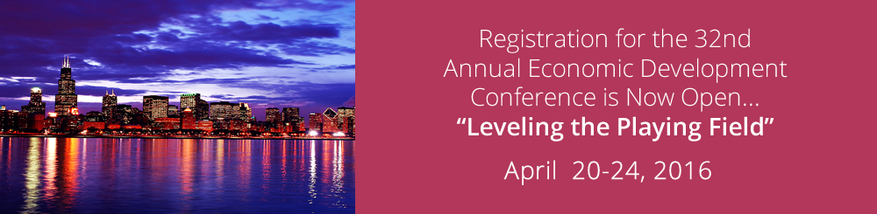](http://nobco.org/inc/wp-content/uploads/2015/02/edc-banner-1000.png)

NOBCO CONFERENCE 2016

CHICAGO , ILLINOIS